Twitter Toolkit for Drug-Impaired Driving in Canada
Purpose: To support CCSA partners in sharing important documents and messages on Twitter about drug-impaired driving. Below you will find tweets in English and French that link to reports and key messages. Images have been included with shorter tweets for their eye-catching nature.
Note: Full URLs (website links) have been included because Twitter.com will automatically shorten them for you. If using a social media content management system like Hootsuite or Tweetdeck, paste the link where directed for shortening.
IN ENGLISH
Tweets with image:
Brief from @CCSACanada: Canada’s Drug Evaluation & Classification Program.

http://www.ccsa.ca/Resource%20Library/CCSA-Drug-Evaluation-Classification-Program-Policy-Brief-2017-en.pdf

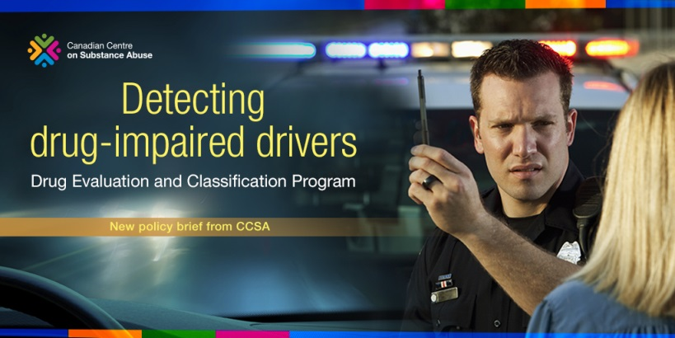

Cannabis Use and Driving: an update from @CCSACanada
http://www.ccsa.ca/Resource%20Library/CCSA-Cannabis-Use-and-Driving-Report-2015-en.pdf

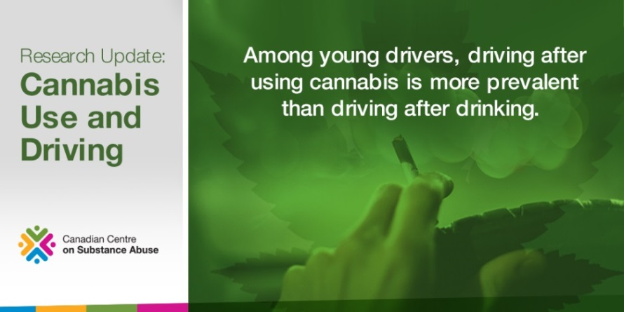
Learn about #Cannabis, Driving & Implications for Youth via @CCSACanada: http://www.ccsa.ca/Resource%20Library/CCSA-Cannabis-Driving-Implications-for-Youth-Summary-2015-en.pdf

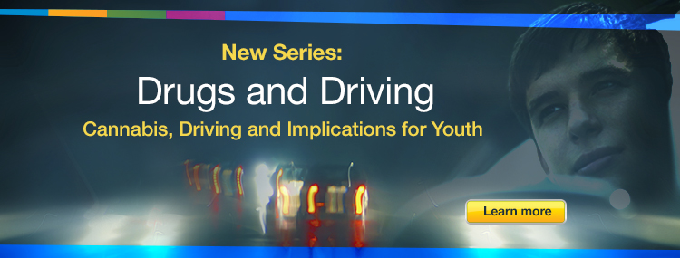

What to know about youth and driving after using opioids? http://www.ccsa.ca/Resource%20Library/CCSA-Opioids-Driving-Implications-for-Youth-Summary-2015-en.pdf via @CCSACanada

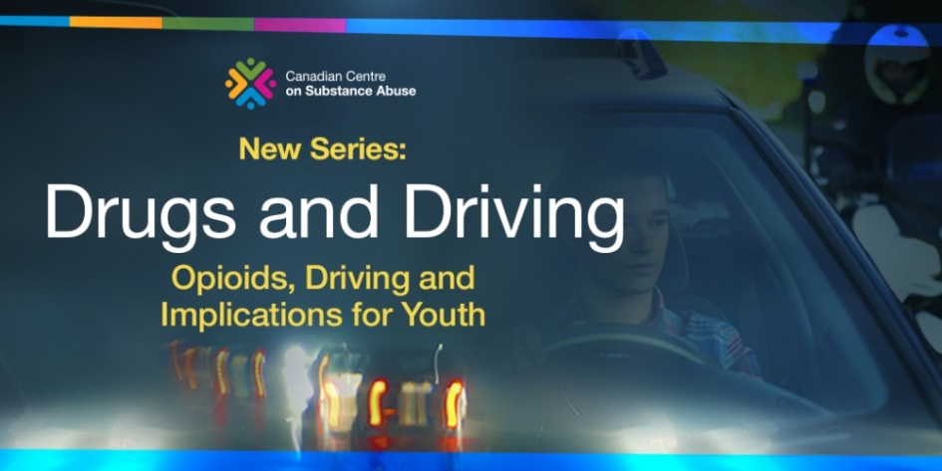

What do youth need to know about stimulants and driving? http://www.ccsa.ca/Resource%20Library/CCSA-Stimulants-Driving-Implications-for-Youth-Summary-2015-en.pdf via @CCSACanada #drugdriving

Tweets without image (allows for more text when no image is included)
Police have authority & tools to detect #drugdriving. Understand risks & consequences via @CCSACanada

http://www.ccsa.ca/Resource%20Library/CCSA-Drug-Evaluation-Classification-Program-Policy-Brief-2017-en.pdf

Many types of illicit & prescription drugs impair a person’s ability to drive - can have deadly results!

http://www.ccsa.ca/Resource%20Library/CCSA-Impaired-Driving-Canada-Summary-2017-en.pdf

What factors make #youth #drug #impaireddriving programs more effective?
http://www.ccsa.ca/Eng/topics/Children-and-Youth/Youth-and-Impaired-Driving/Pages/default.aspx

What is a “per se” #drug law? View policy brief from @CCSACanada:
http://www.ccsa.ca/Resource%20Library/CCSA-Drug-per-Se-Laws-Policy-Brief-2017-en.pdf

